## EASY LEAVE

## A leave management software.

## INDEX

**PARTICULARS**

**SL.NO**

1. **Introduction**
2. **Objectives**
3. **Existing System**
4. **Proposed System**
5. **Hardware and Software requirements**
6. **Data Flow Diagram**
7. **Class Diagram**
8. **Use Case Modeling**
9. **Sequence Diagram**
10. **Activity Diagram**
11. **Conclusion**
12. **Bibliography**

## INTRODUCTION

## There may be multiple reasons to write a leave application or a leave letter. A leave letter can be written by a student to the principal, an employee to the manager or HR, a teacher to the principal, a student to the hostel warden, etc. When you want to take leave. you will have to seek permission from your higher authority.

**Reasons for Applying for Leave**

There may be multiple reasons for taking leave. While writing a leave letter, it is very essential to mention the reason behind the leave request, irrespective of whether you are working or studying. Reasons of absence can vary. Some of them can be:

* Illness or any other medical needs
* Taking rest or recovery from illness
* A marriage function, birthday, anniversary, or any other family functions
* Travelling with family or friends

**What is use our software?**

* Our leave software allows its user to apply leave to their higher authority easily. It will reduce the paper work of old process of applying leave.
* By using our software, the applier and manger can have all the history of existing leaves.
* we have emergency leave features where the applier can take quick leave according to their situations.
* All the content of user and manager are secured with user id and password so that someone else cannot access it.
* When any organisation uses our software there will two main section one section for applier and another section for leave manager with easy software interface.

**Objectives of developing this** **software**

* To get better adopted to the modern technology.
* To reduce the human work load.
* This software will save time of the user.
* To store all the record in one place.
* Providing emergency leave feature.
* As human can forget thing during pass of time by using our software, they can have all the history records.
* User can easily and without any hesitation can apply for leave.
* To get solution for all the problems.
* To make everything easy and understand better.

**Existing system**

* In existing system leave process is carried out manually.
* Users and manager can have the fear of losing records.
* There is no security for record.
* You cannot check the history of leave applied.
* For Appling leave you need to visit the office of particular organisation.
* Requires more time as it involves the paper work and approval for process.
* User does not get approved or disapproved notification at the time.
* User cannot ask for the quick leave.
* You cannot apply for leaves if there is holiday or office is close.
* Manager cannot manage all the leave of different department of organisation at once.

**Proposed syste****m**

* Conserves the user time.
* User get notification of approval or disapproval at the time.
* There is less paper work as the process carried through software.
* User can have all the record of past leave in their history section.
* Both applier and manager work are reduced as the process is caried out through our software.
* There will we security to user data.
* Manger can manage leave all the department at one place by using our software.
* We have the quick leave for the emergency situation.
* Leave can be applied during holiday and also without going to office many times.

**Hardware and software requirements**

Here is information about minimum software and hardware requirement used to develop this application software.

**Software specification:**

* Windows: - 8.1, 10, 11.
* Front end: - C#, Visual Studio 2019
* Back end: - Microsoft My SQL Server 2019
* Frame Work: - .Net Framework 4.7.2

**Hardware specification:**

* RAM: - 2 GB
* Processor: - intel Pentium or above.
* HHD or SSD: -50 GB minimum.
* Monitor: - Good monitor with 50% RGB colour gamut.
* Printer: - 80 columns colour printer.

**DIAGRAMS**

**Context level: Data flow diagram**

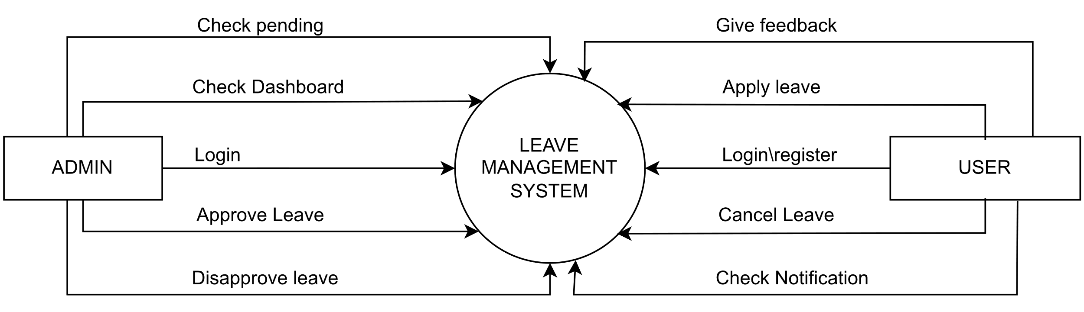

**Level 1.0**

**Data flow diagram user**

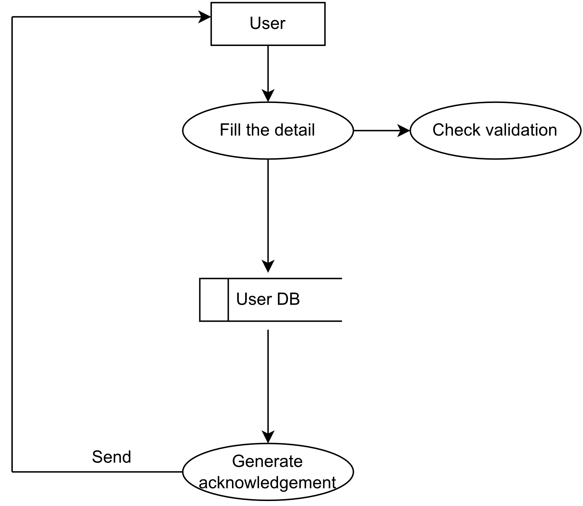

**Level 1.1**

**Data flow diagram user**

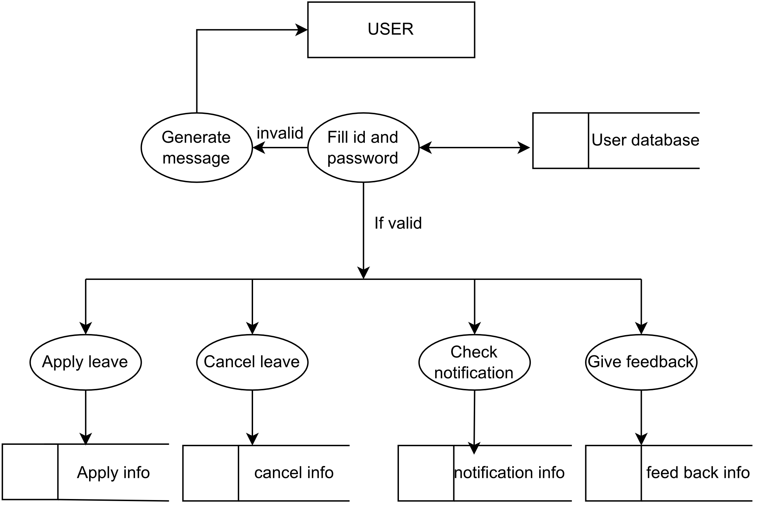

**Level 2.0**

**Data flow diagram for manager**

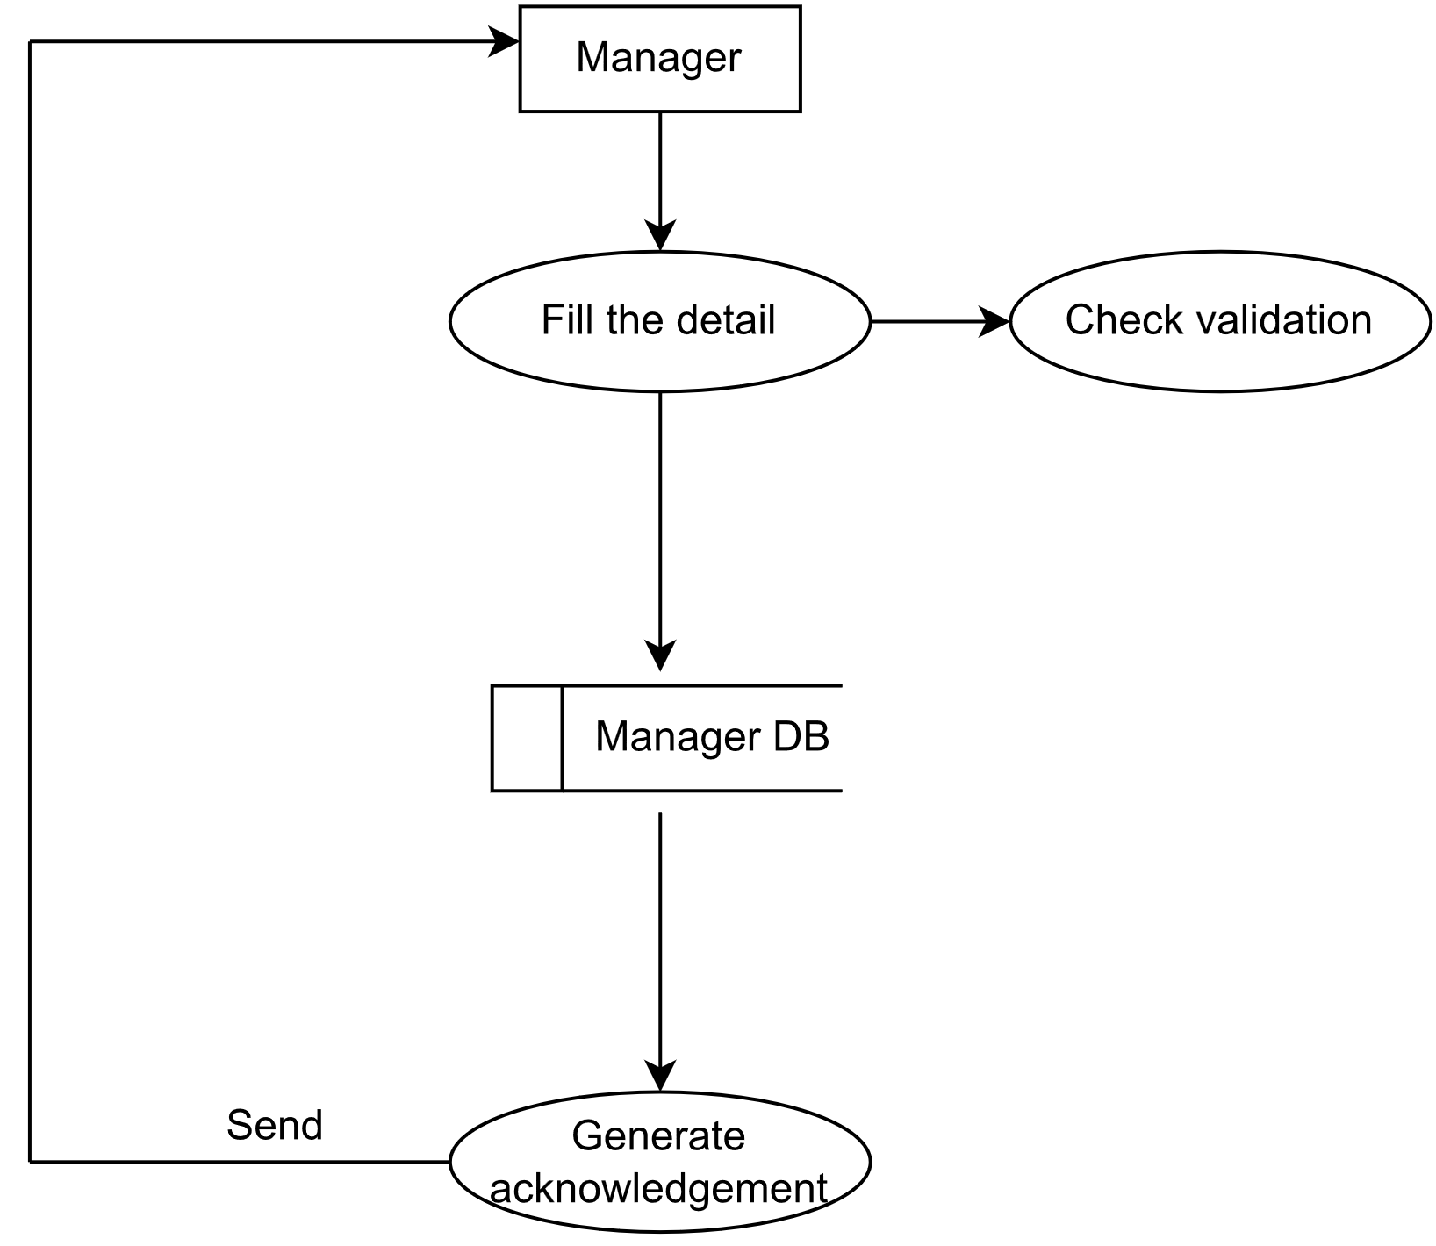

**Level 2.1**

**Data flow diagram for manager**

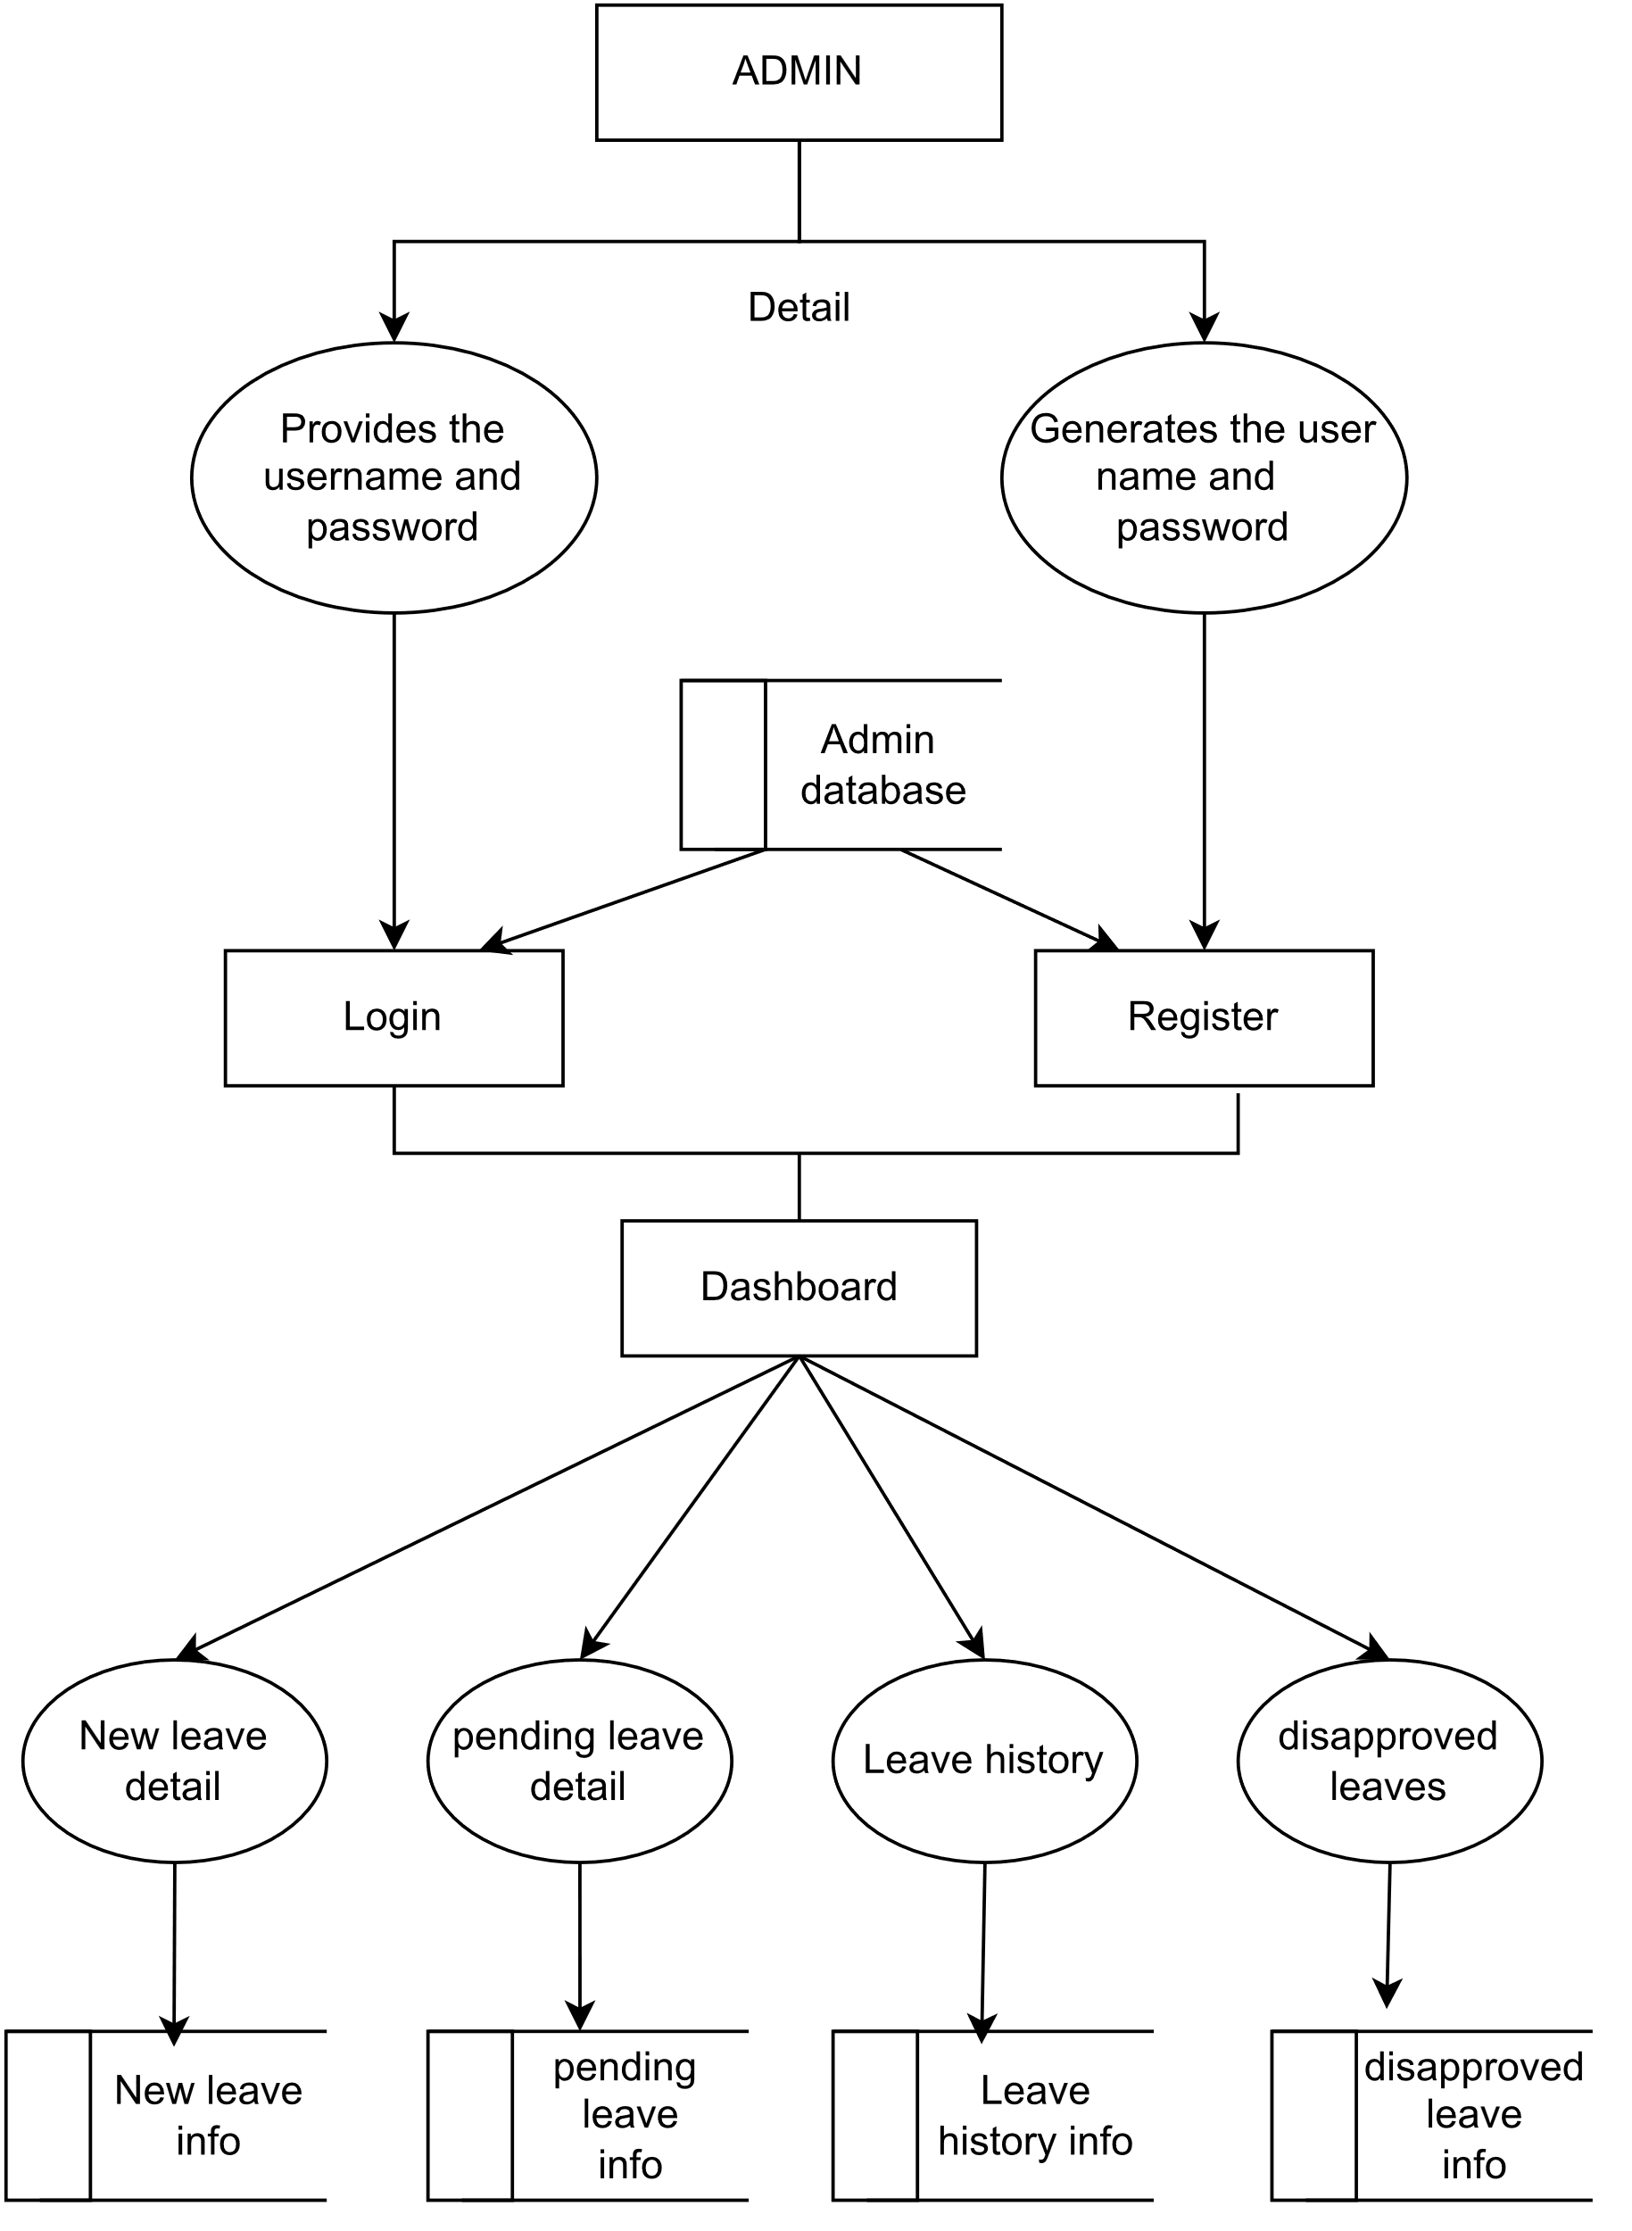

**CLASS DIAGRAM**

**ADMIN_INFO**

**APPROVAL**

**\*String : uid  
*String : uname  
*String : accepted  
*String : regno  
*String : adate**

**ADMIN**

**\*String : regno  
*String : username  
*String : Address  
*String : E_name  
*String : Ph_no**

**+approve()**

**+Add()  
+Update()**

**DISAPPROVAL**

**\*String : uid  
*String : uname  
*String : accepted  
*String : regno  
*String : adate**

**USER_INFO**

**USERS**

**+disapprove()**

**PENDING**

**\*String : uid  
*String : uname  
*String : uaddress  
*String : uE_name  
*String : uPh_no  
*String : regno**

**\*String : uid  
*String : uname  
*String : pending  
*String : regno  
*String : ldate**

**LEAVE_INFO**

**LEAVE**

**\*String : uid  
*String : uname  
*String : uaddress  
*String : uE_name  
*String : uPh_no  
*String : regno**

**NOTIFICATION**

**\*String : uid  
*String : uname  
*String : uaddress  
*String : uE_mail  
*String : uPh_no  
*String : regno  
*String : description  
*String : ldate**

**+notify()**

**+Update()  
+View()**

**e()**

**Use case diagram**

Use case diagram is methodology used in system analysis, clarify and organize system requirements. The use case diagram is made of set of possible sequence of interaction between system and users in a particular environment and related to a particular goal.

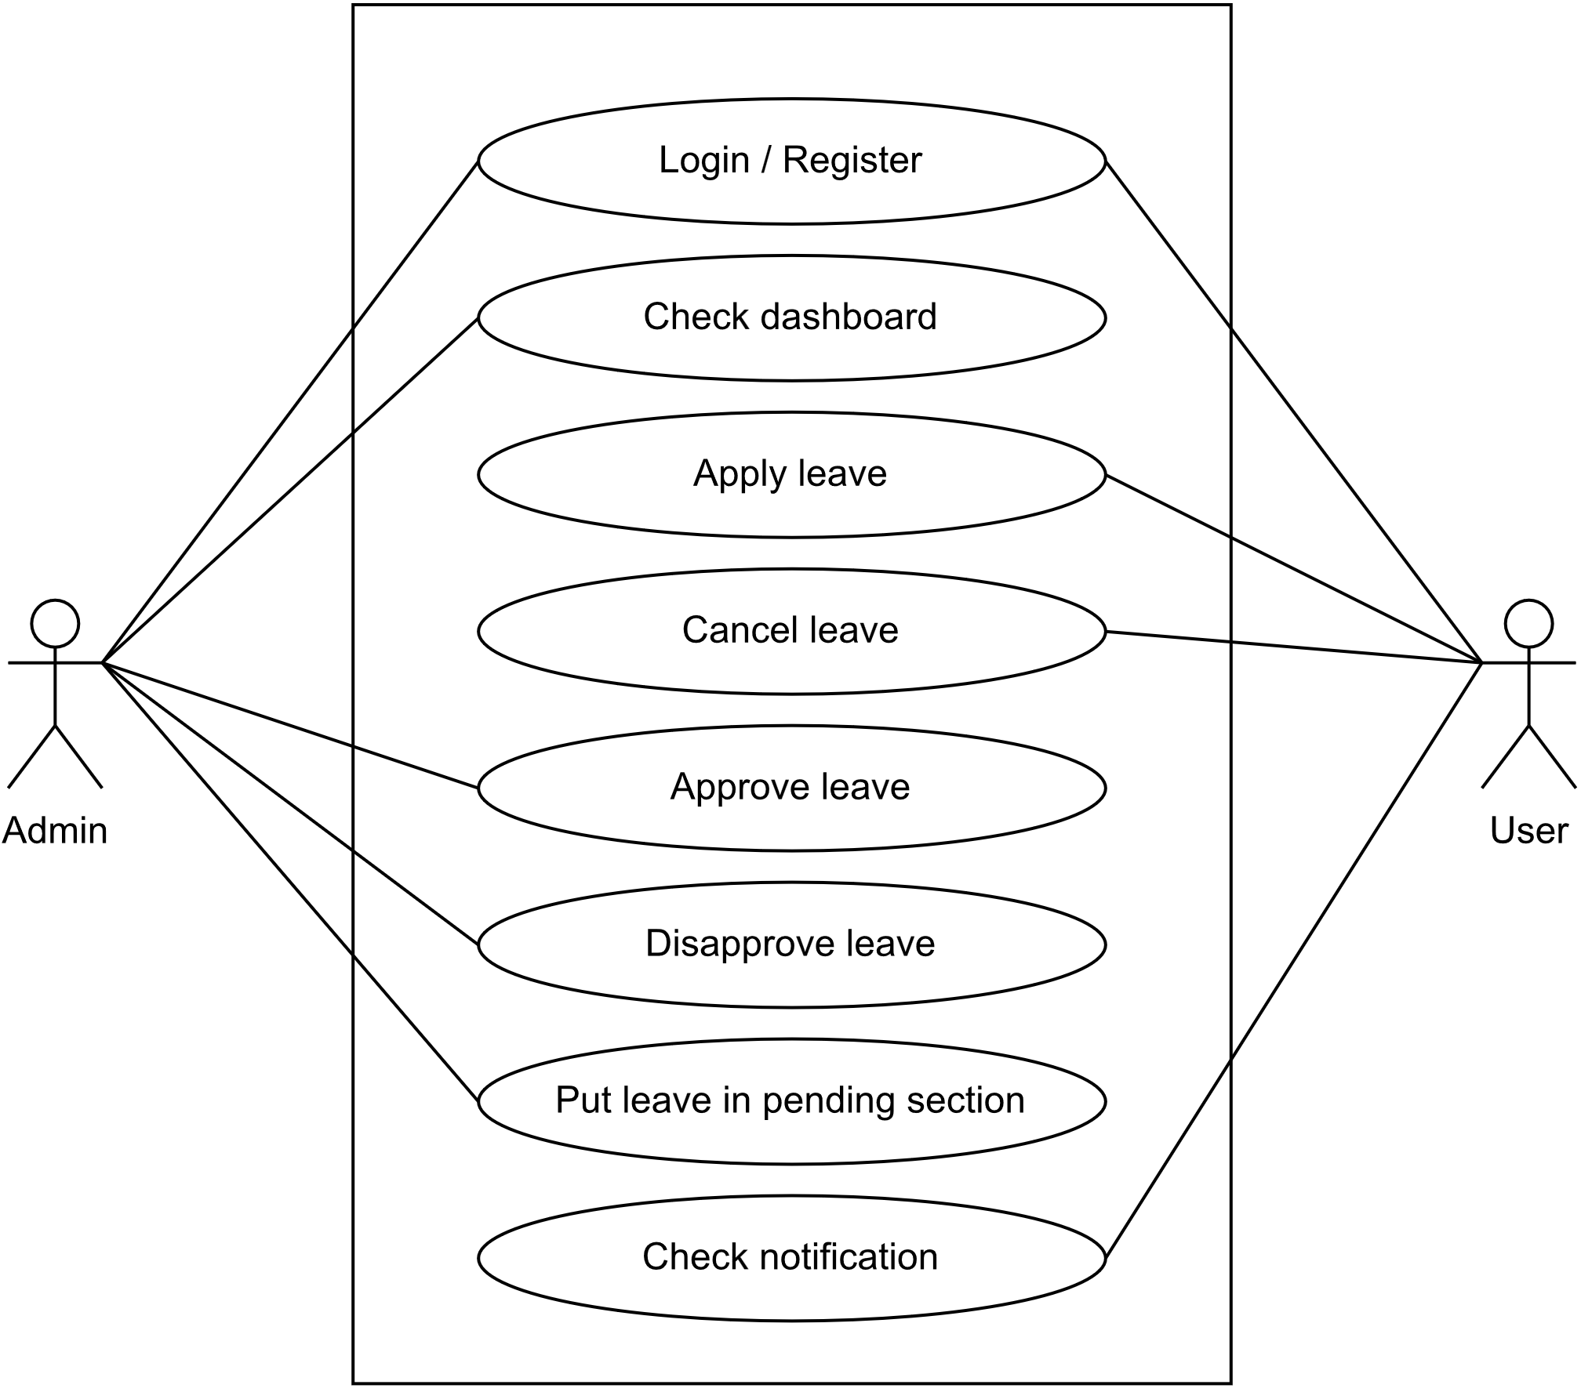

**Sequence diagram for user**

Sequence diagram is a diagram show object interaction in time sequence. Particularly it shows object participation in the interaction and the sequence of message exchanged.

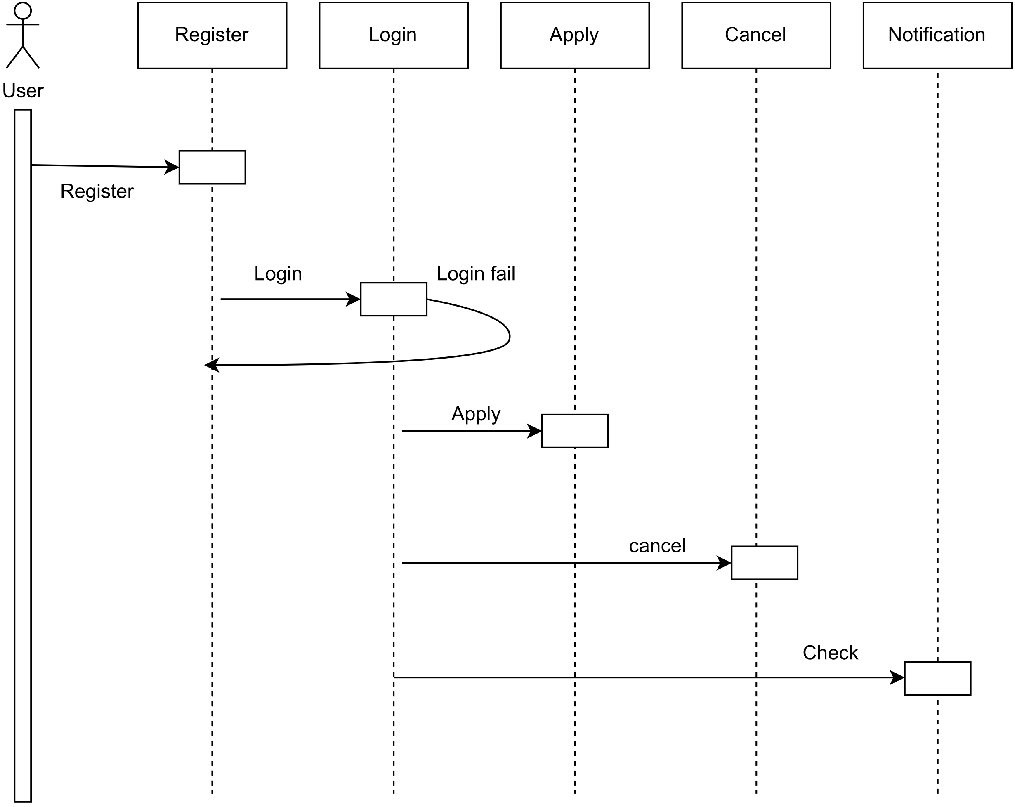

**Sequence diagram for admin**

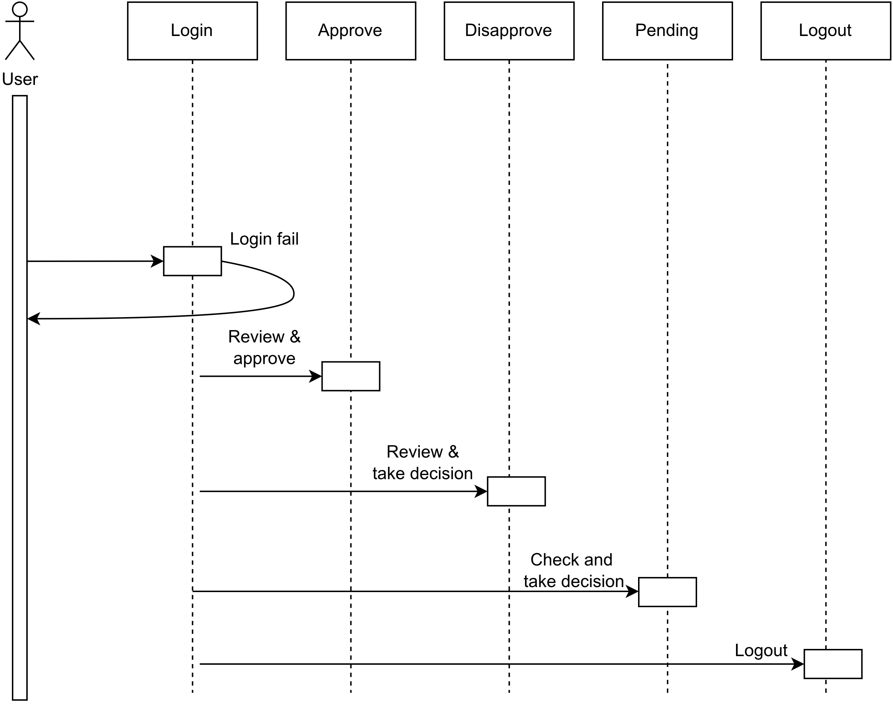

**Activity diagram for admin**

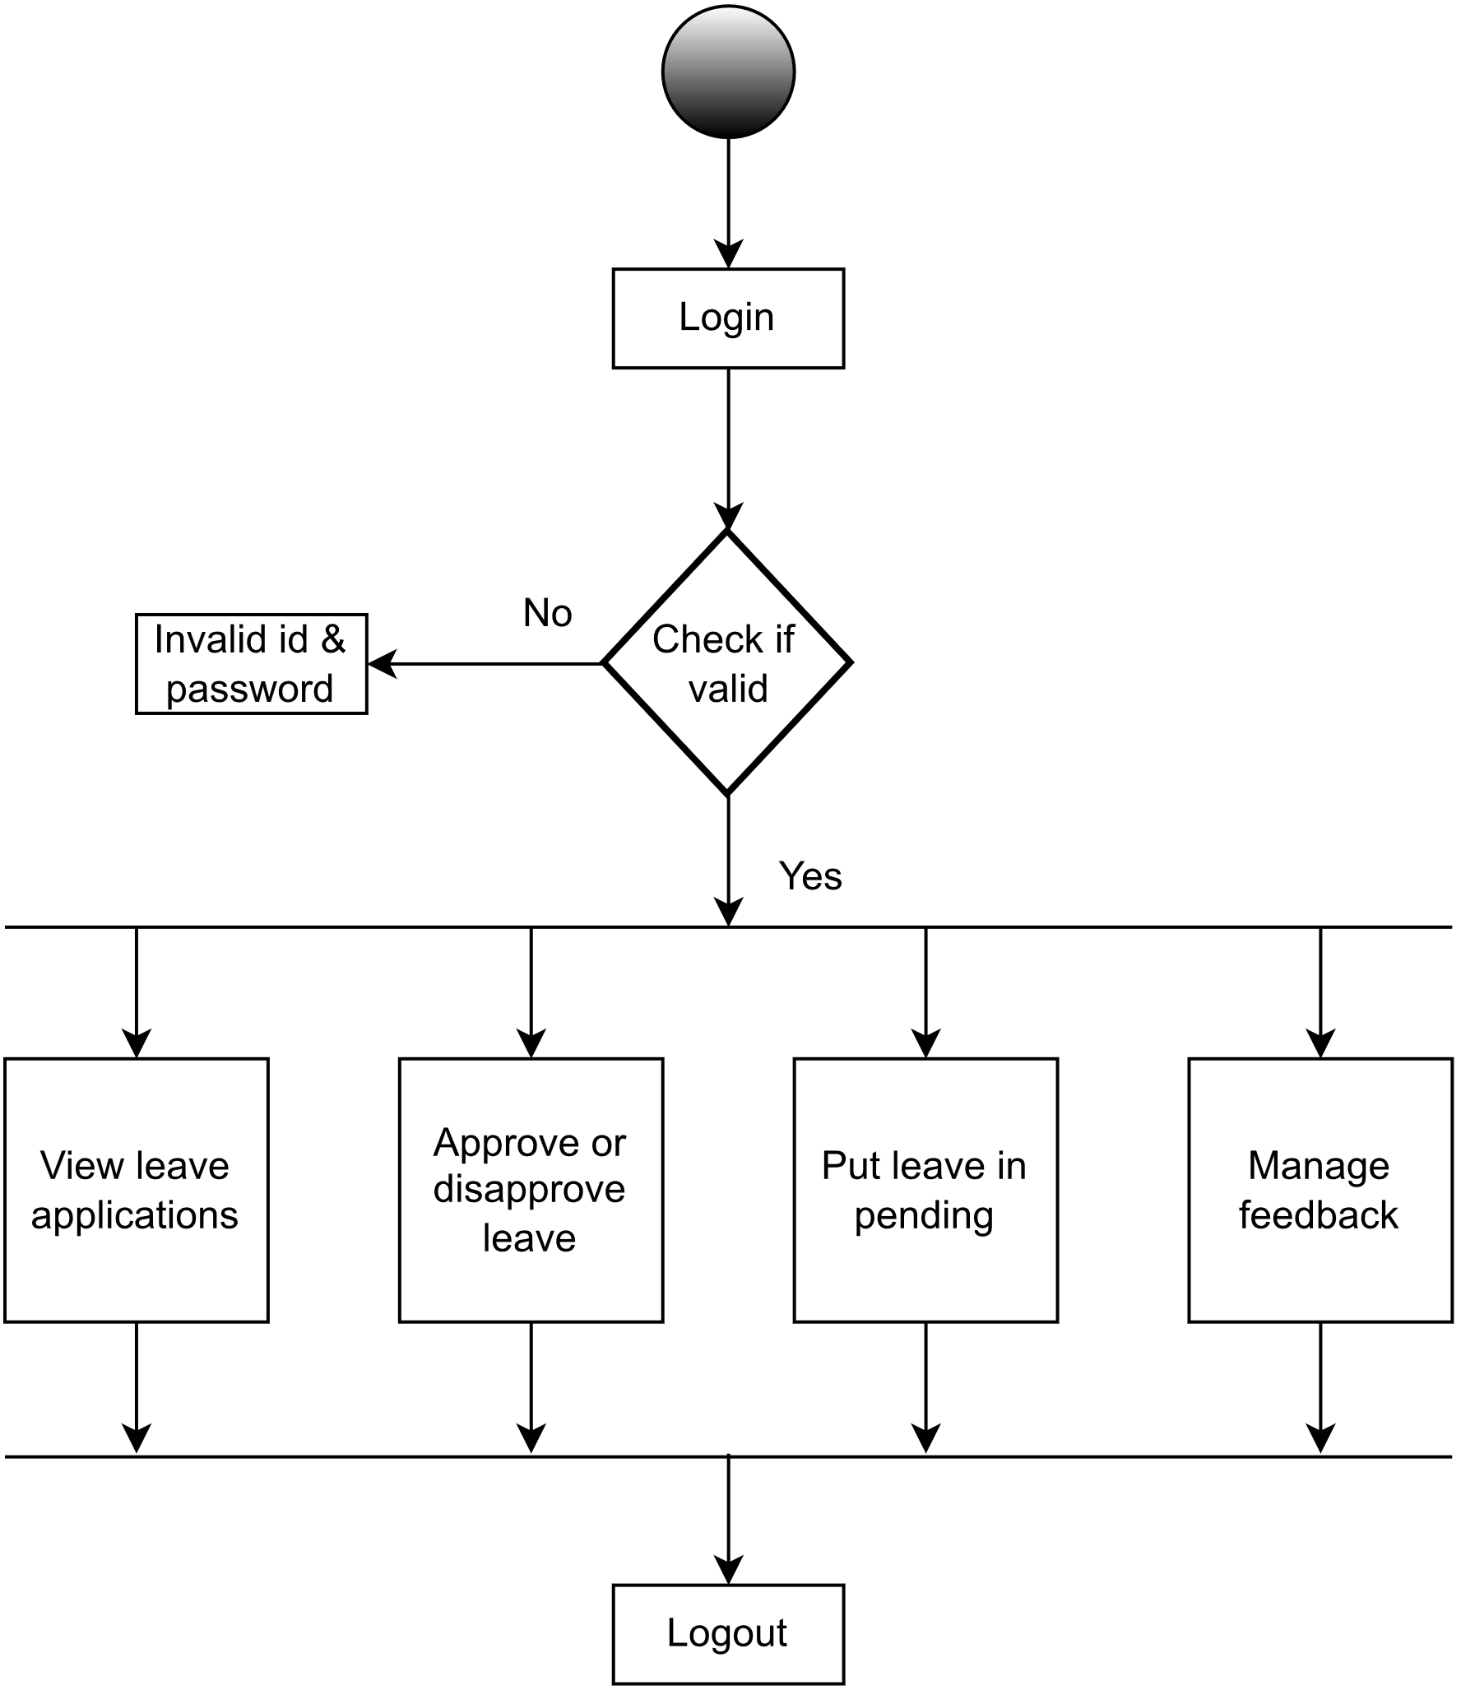

**Activity diagram for user**

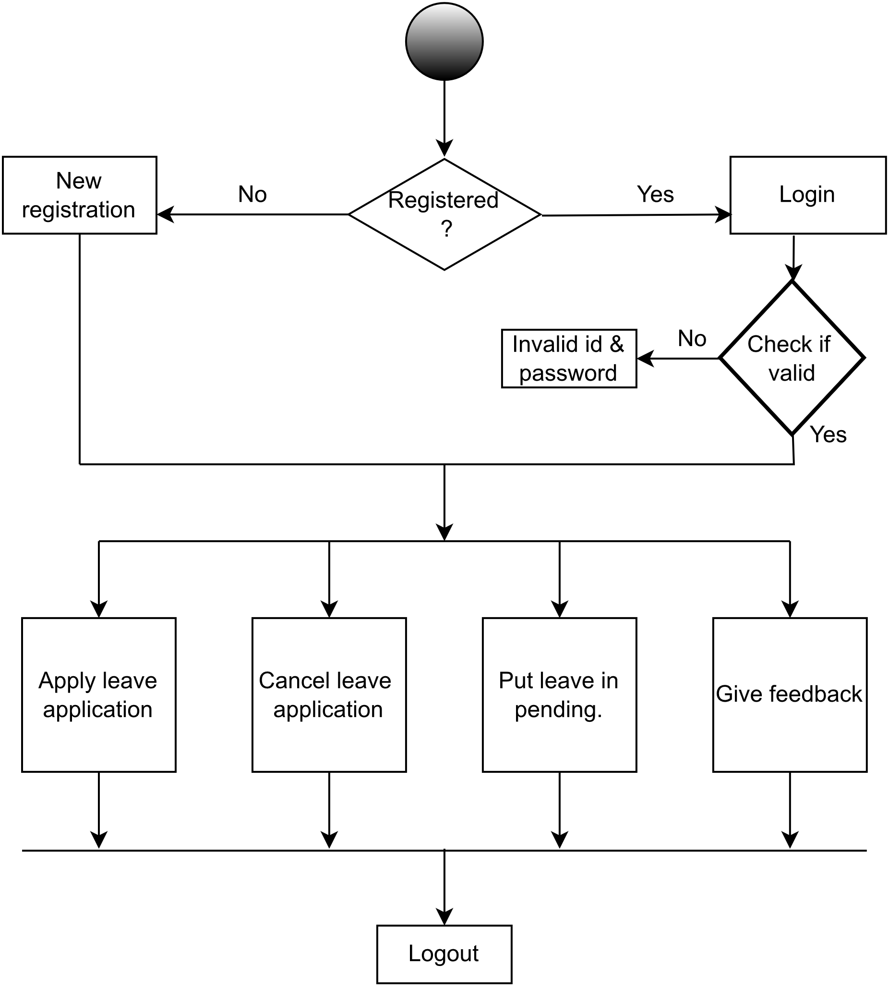

**CONCLUSION**

**This LEAVE MANAGEMENT SYSTEM helps the admin to view and manage the leaves applied by their users.**

**This management system provides the approval, disapproval, pending and notifying functions which makes the work of admin easier.**

**This software helps the admin leading to saving time.**

**BIBLIOGRAPHY**

**Websites referred are :**

* [**www.slideshare.com**](http://www.slideshare.com)
* [**www.freeproject.com**](http://www.freeproject.com)
* [**www.nevonproject.com**](http://www.nevonproject.com)
* [**www.javatpoint.com**](http://www.javatpoint.com)